5.IMPLEMENTATION OF ARRAY AND BINARY SEARCH TREE TRAVERSAL OPERATIONS IN C++

AIM:
To write and implement C++ programs to perform traversal operations on arrays and a Binary Search Tree, including array traversal, function-based traversal, even-element traversal, and inorder, preorder, and postorder traversals of a BST.

5.1. Write a C++ program to perform the traversal operation on an array. The program should read n elements from the user and display all the elements by traversing the array.

ALGORITHM:
Step 1: Start the program.
Step 2: Declare an array and read the number of elements n from the user.
Step 3: Read n elements into the array.
Step 4: Set the array index i to 0.
Step 5: Traverse the array from index 0 to n-1.
Step 6: Display each array element during traversal.
Step 7: Stop the program.

PROGRAM:
#include <iostream>
using namespace std;
int main()
{
int arr[100], n;
cout << "Enter the number of elements: ";
cin >> n;
cout << "Enter the array elements:\n";
for (int i = 0; i < n; i++)
{
cin >> arr[i];
}
cout << "\nArray elements are:\n";
for (int i = 0; i < n; i++)
{
cout << arr[i] << " ";
}
return 0;
}

OUTPUT:
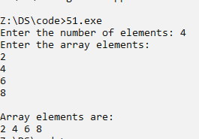

5.2. Write a C++ program to perform the traversal operation on an array. The program should accept n elements from the user and display the array elements using a separate traversal function.

ALGORITHM :
Step 1: Start the program.
Step 2: Declare an array and read the number of elements n from the user.
Step 3: Read n elements into the array.
Step 4: Call the traverse() function by passing the array and its size.
Step 5: In the traverse() function, set the index i to 0.
Step 6: Traverse the array from index 0 to n-1.
Step 7: Display each array element.
Step 8: Return control to the main() function.
Step 9: Stop the program.

PROGRAM:
#include <iostream>
using namespace std;
void traverse(int arr[], int n)
{
cout << "\nArray Elements are:\n";
for (int i = 0; i < n; i++)
{
cout << arr[i] << " ";
}
cout << endl;
}
int main()
{
int arr[50], n;
cout << "Enter the number of elements: ";
cin >> n;
cout << "Enter the array elements:\n";

for (int i = 0; i < n; i++)
{
cin >> arr[i];
}
traverse(arr, n);
return 0;
}

OUTPUT:
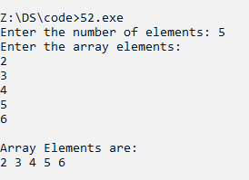

5.3. Write a C++ program to traverse an array and print only the even numbers stored in the array.

ALGORITHM :
Step 1: Start the program.
Step 2: Declare an array and read the number of elements n from the user.
Step 3: Read n elements into the array.
Step 4: Set the array index i to 0.
Step 5: Traverse the array from index 0 to n-1.
Step 6: Check whether each element is divisible by 2 using the condition arr[i] % 2 == 0.
Step 7: If the condition is true, display the element.
Step 8: Continue the traversal until all elements are checked.
Step 9: Stop the program.

PROGRAM:
#include <iostream>
using namespace std;
int main()
{
int arr[100], n;
cout << "Enter the number of elements: ";
cin >> n;
cout << "Enter the array elements:\n";
for (int i = 0; i < n; i++)
{
cin >> arr[i];
}
cout << "\nEven elements are:\n";
for (int i = 0; i < n; i++)
{
if (arr[i] % 2 == 0)
cout << arr[i] << " ";
}
return 0;
}
OUTPUT:
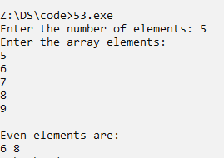

5.4. Write a C++ program to create a Binary Search Tree (BST) and perform the following traversal operations:
Inorder Traversal
Preorder Traversal
postorder Traversal

ALGORITHM :
Step 1: Start the program.
Step 2: Create a Binary Search Tree with the root initially set to NULL.
Step 3: Insert the elements into the BST according to the BST property: smaller values are inserted into the left subtree and larger or equal values into the right subtree.
Step 4: For Inorder Traversal, recursively traverse the left subtree.
Step 5: Visit and display the root node.
Step 6: Recursively traverse the right subtree.
Step 7: For Preorder Traversal, visit and display the root node first.
Step 8: Recursively traverse the left subtree and then the right subtree.
Step 9: For Postorder Traversal, recursively traverse the left subtree.
Step 10: Recursively traverse the right subtree.
Step 11: Visit and display the root node.
Step 12: Display the results of inorder, preorder, and postorder traversals.
Step 13: Stop the program.

PROGRAM:
#include <iostream>
using namespace std;
class Node
{
public:
int data;
Node *left, *right;
Node(int value)
{
data = value;
left = right = NULL;
}
};
class BST
{
public:
Node *root;
BST()
{
root = NULL;
}
Node* insert(Node *root, int value)
{
if (root == NULL)
return new Node(value);
if (value < root->data)
root->left = insert(root->left, value);
else
root->right = insert(root->right, value);
return root;
}
void inorder(Node *root)
{
if (root != NULL)
{
inorder(root->left);
cout << root->data << " ";
inorder(root->right);
}
}
void preorder(Node *root)
{
if (root != NULL)
{
cout << root->data << " ";
preorder(root->left);
preorder(root->right);
}
}
void postorder(Node *root)
{
if (root != NULL)
{
postorder(root->left);
postorder(root->right);
cout << root->data << " ";
}
}
};
int main()
{
BST tree;
tree.root = tree.insert(tree.root, 50);
tree.root = tree.insert(tree.root, 30);
tree.root = tree.insert(tree.root, 70);
tree.root = tree.insert(tree.root, 20);
tree.root = tree.insert(tree.root, 40);
tree.root = tree.insert(tree.root, 60);
tree.root = tree.insert(tree.root, 80);
cout << "Inorder Traversal: ";
tree.inorder(tree.root);
cout << "\nPreorder Traversal: ";
tree.preorder(tree.root);
cout << "\nPostorder Traversal: ";
tree.postorder(tree.root);
return 0;
}

OUTPUT:
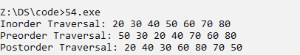

RESULT:
Thus, the C++ programs for performing traversal operations on arrays and a Binary Search Tree were successfully implemented and executed. The array elements, even elements, and BST traversal sequences were displayed successfully.

